Requirement Analysis Phase
Technology Stack (Architecture & Stack)
Date | 28 October 2026
Team ID | To Be Confirmed
Project Name | HotelPro – Hotel Management System
Maximum Marks | 4 Marks
Document Status | Draft v1.0 – prepared from the stated HotelPro requirements. No HotelPro source code has been provided or verified, so all features are marked Planned.

1. Technical Architecture
HotelPro is designed as a three-tier web application: a presentation layer (React single-page application), a business-logic layer (Node.js and Express.js REST API organised in an MVC style) and a data layer (MongoDB accessed through Mongoose). The design supports secure role-based access, integration with a payment gateway and an email service, and later scaling of the API and database. Components marked Planned are part of the intended stack but have not been verified against source code.
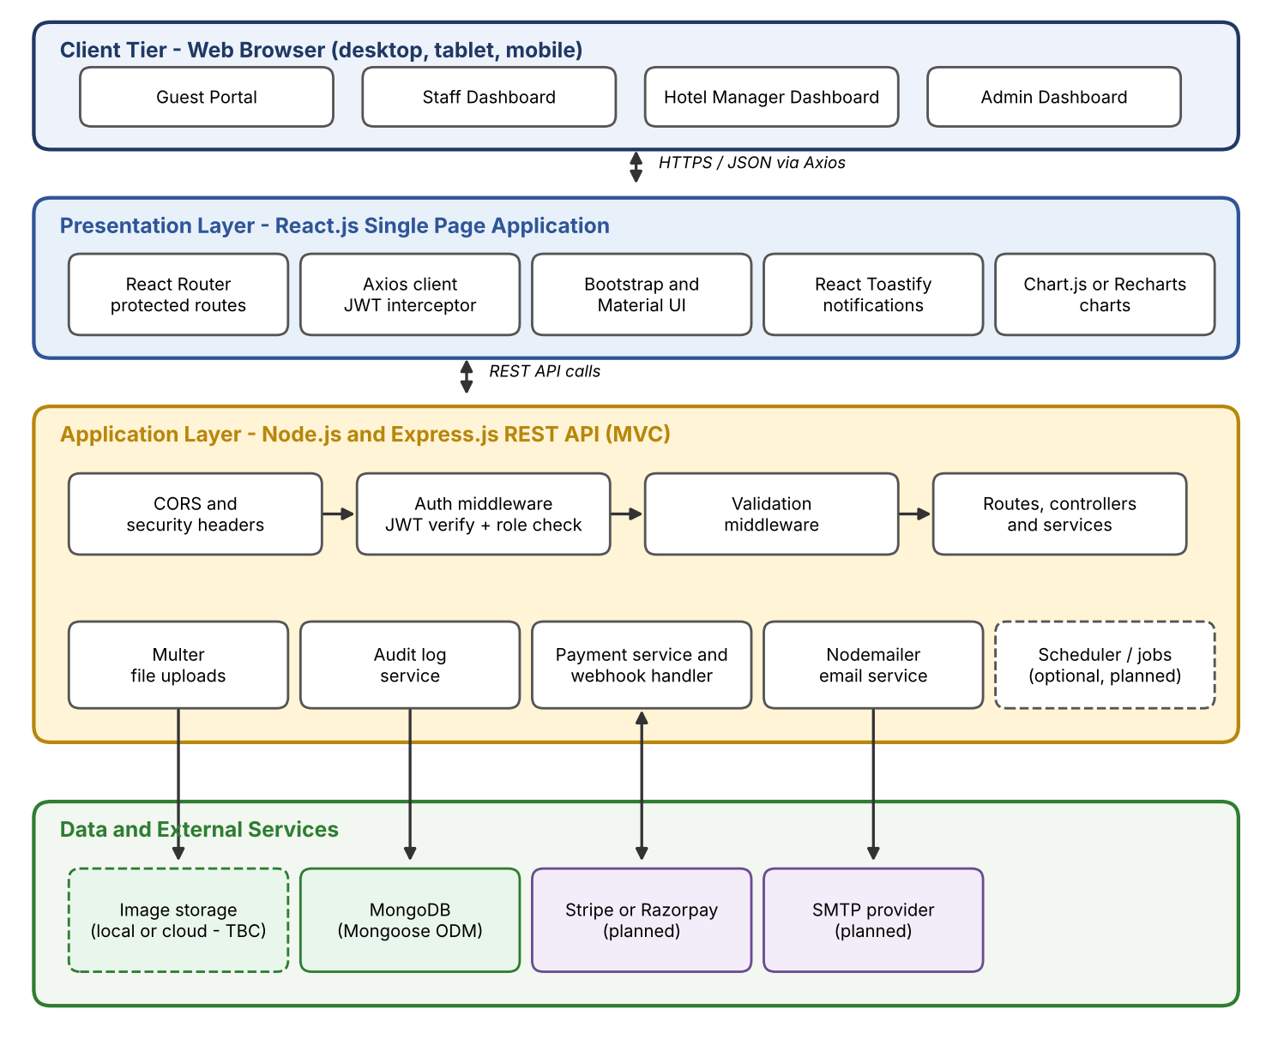
Figure 1: HotelPro technical architecture (three-tier)

2. Components and Technologies
Table 1: Table-1: Components & Technologies
S.No | Component | Description | Technology | Status
1 | User Interface | Responsive web interface for guests, staff, managers and admins | React.js, React Router, Bootstrap, Material UI (where applicable) | Planned
2 | Application Logic-1 | Authentication, rooms, bookings, payments, reviews, notifications APIs | Node.js, Express.js | Planned
3 | Application Logic-2 | Staff operations, hotel management, admin console, reports | Node.js, Express.js, Chart.js or Recharts (charts on the frontend) | Planned
4 | Database | Stores users, hotels, rooms, bookings, payments, reviews, notifications, logs | MongoDB with Mongoose ODM | Planned
5 | File / Image Storage | Room images and uploads | Multer (local disk or cloud storage – To Be Confirmed) | Planned
6 | Authentication | Token-based login and password hashing | JSON Web Tokens (jsonwebtoken), bcryptjs | Planned
7 | Email Service | Verification, confirmation and alert emails | Nodemailer with an SMTP provider (To Be Confirmed) | Planned
8 | Payment Gateway | Online payments and refunds | Stripe or Razorpay (final choice To Be Confirmed) | Planned
9 | Client Feedback | Toast notifications for success and error messages | React Toastify | Planned
10 | Cross-origin & Config | CORS policy and environment configuration | CORS, dotenv | Planned

Table 2: Table-2: Application Characteristics
S.No | Characteristics | Description | Technology
11 | Open-Source Frameworks | Frontend and backend frameworks and UI libraries | React.js, Node.js, Express.js, Bootstrap, Material UI
12 | Scalable Architecture | 3-tier architecture with stateless REST APIs; horizontal scaling possible | MVC, REST, JWT (stateless)
13 | Security Implementation | Hashed passwords, token authentication, role-based authorisation, validation | bcryptjs, JWT, RBAC middleware, validation library (To Be Confirmed)
14 | Data Visualisation | Occupancy, revenue and booking charts | Chart.js or Recharts (one to be selected)
15 | Deployment | Cloud hosting of frontend, API and database; optional CDN and load balancer | To be selected (e.g., static hosting, Node hosting, MongoDB Atlas)

3. Library Inventory
The libraries below are those named in the project brief, plus recommended supporting libraries marked “Recommended addition”. Versions are To Be Confirmed against the source code’s package.json files.
Table 3: Library inventory
Layer | Package | Purpose | Basis
Backend | express | HTTP server and routing | Stated stack
Backend | mongoose | MongoDB schemas, validation and queries | Stated stack
Backend | jsonwebtoken | Issue and verify JWTs | Stated stack
Backend | bcryptjs | Password hashing | Stated stack
Backend | cors | Cross-origin policy for the client URL | Stated stack
Backend | dotenv | Load environment variables | Stated stack
Backend | multer | Multipart uploads (room images) | Stated stack
Backend | nodemailer | Send emails | Stated stack
Backend | stripe or razorpay | Payment gateway SDK | Stated stack (choice TBC)
Backend | nodemon | Auto-restart in development | Recommended addition
Backend | helmet, express-rate-limit | Secure headers and brute-force throttling | Recommended addition
Backend | express-validator or Joi | Request validation | Recommended addition (TBC)
Backend | morgan | HTTP request logging | Recommended addition
Frontend | react, react-dom, react-router-dom | UI and client-side routing | Stated stack
Frontend | axios | HTTP client with interceptors | Stated stack
Frontend | bootstrap, @mui/material | Layout and components | Stated stack
Frontend | react-toastify | Notifications | Stated stack
Frontend | chart.js (react-chartjs-2) or recharts | Dashboards and reports | Stated stack (choice TBC)

4. Architectural Decisions Summary
- Stateless JWT authentication keeps the API horizontally scalable; role claims are verified on every request.
- MongoDB with Mongoose suits flexible hotel, room and booking documents while schemas enforce validation.
- Server-side payment verification (signature/webhook) ensures a booking is confirmed only after genuine payment.
- MVC separation (routes → controllers → services → models) keeps business logic testable.

References
- React Documentation – https://react.dev/
- Node.js Documentation – https://nodejs.org/en/docs
- Express.js Guide – https://expressjs.com/
- Mongoose Documentation – https://mongoosejs.com/docs/
- MongoDB Manual – https://www.mongodb.com/docs/manual/
- JSON Web Token (RFC 7519) – https://datatracker.ietf.org/doc/html/rfc7519
- Stripe Documentation – https://docs.stripe.com/
- Razorpay Documentation – https://razorpay.com/docs/
- Nodemailer – https://nodemailer.com/
- React Router – https://reactrouter.com/
- Material UI – https://mui.com/material-ui/
- Bootstrap – https://getbootstrap.com/docs/
- Chart.js – https://www.chartjs.org/docs/
- Recharts – https://recharts.org/

